## Lab3 RTK GPS Report

1. **ISEC Stationary**

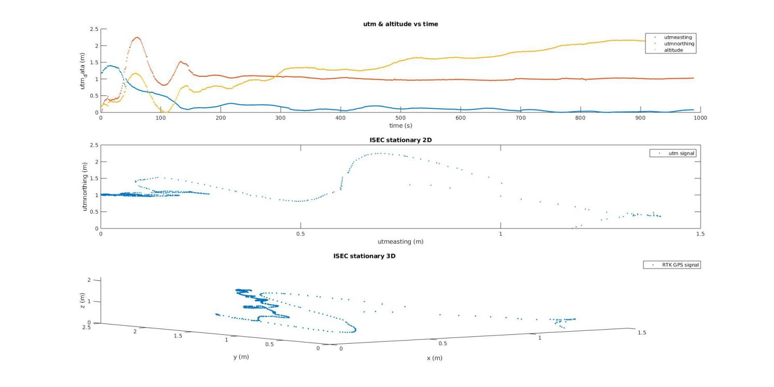

*Figure 1: ISEC stationary RTK GPS plotting*

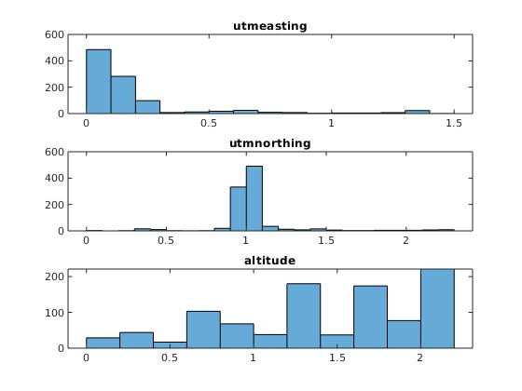

*Figure 2: ISEC stationary RTK GPS Histogram*

1. **Open Space(football field) Stationary**

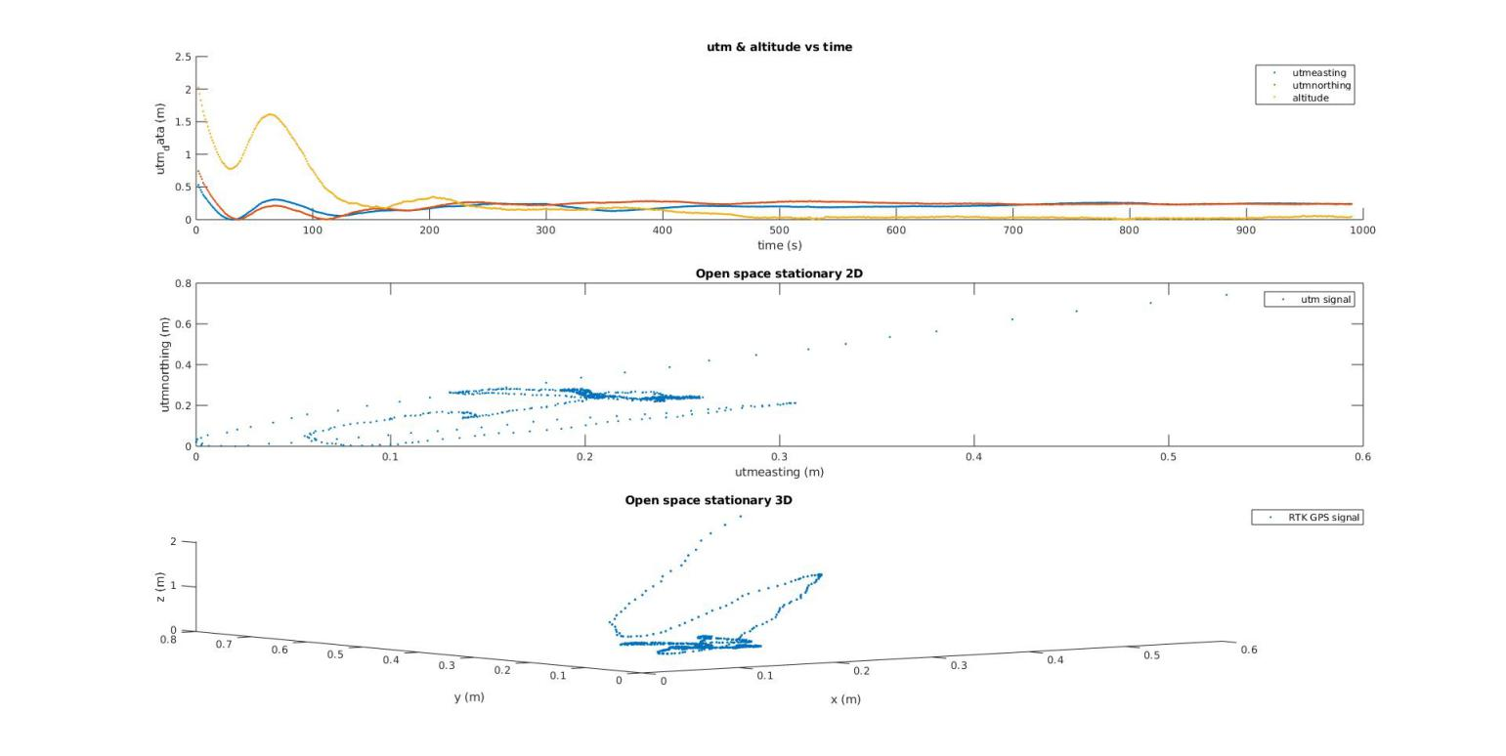

*Figure 3: Open Space stationary RTK GPS plotting*

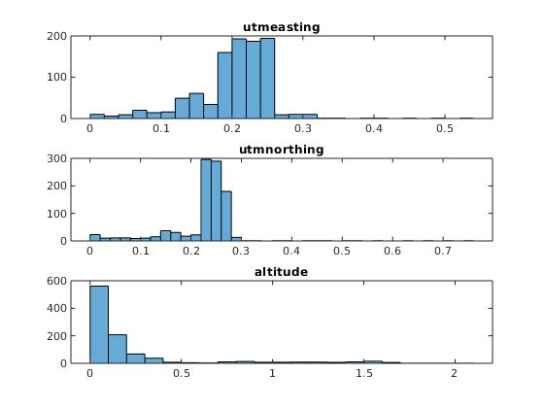

*Figure 4: Open Space stationary RTK GPS Histogram*

**Conclusion:**

When we collected data near ISEC building, there is signal occlusion and GPS received different threads of signals coming from the reflection of the nearby buildings. The precision of RTK is to 1 meter level, which is not as accurate as the result we collected on the football field.

When we were in a football field, RTK GPS signal reached higher accuracy because there was no occlusion. The base and rover GPS communicated in real time on carrier circle to generate centimeter level accuracy.

In a word, the performance of RTK GPS is much better than that of GPS in LAB1.

In LAB1, there’s huge drift in both utm and altitude whereas RTK GPS became more and more accurate over time.

1. **ISEC Walk**

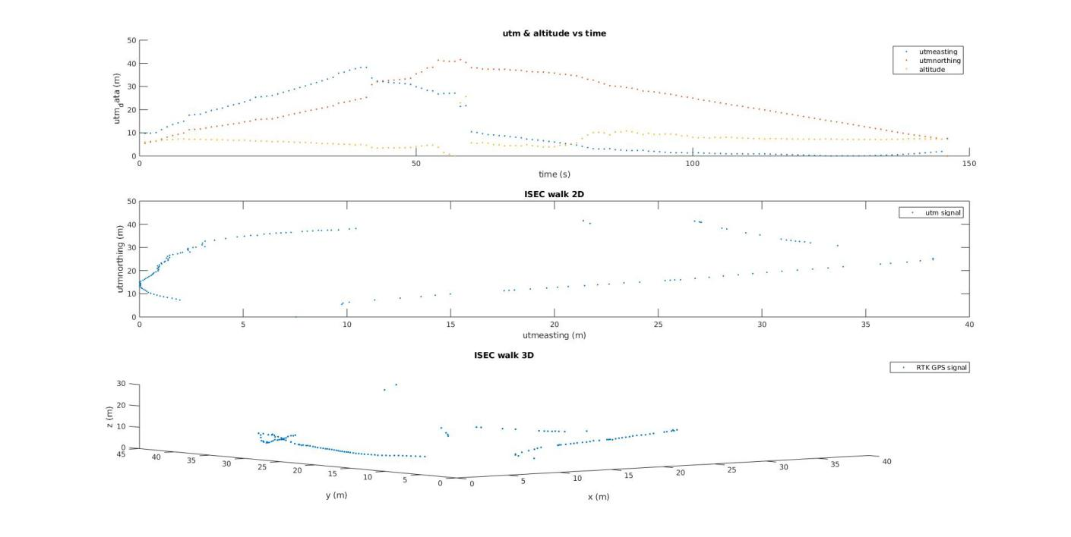

*Figure 5: ISEC Walk RTK GPS plotting*

1. **Open Space(football field) Walk**

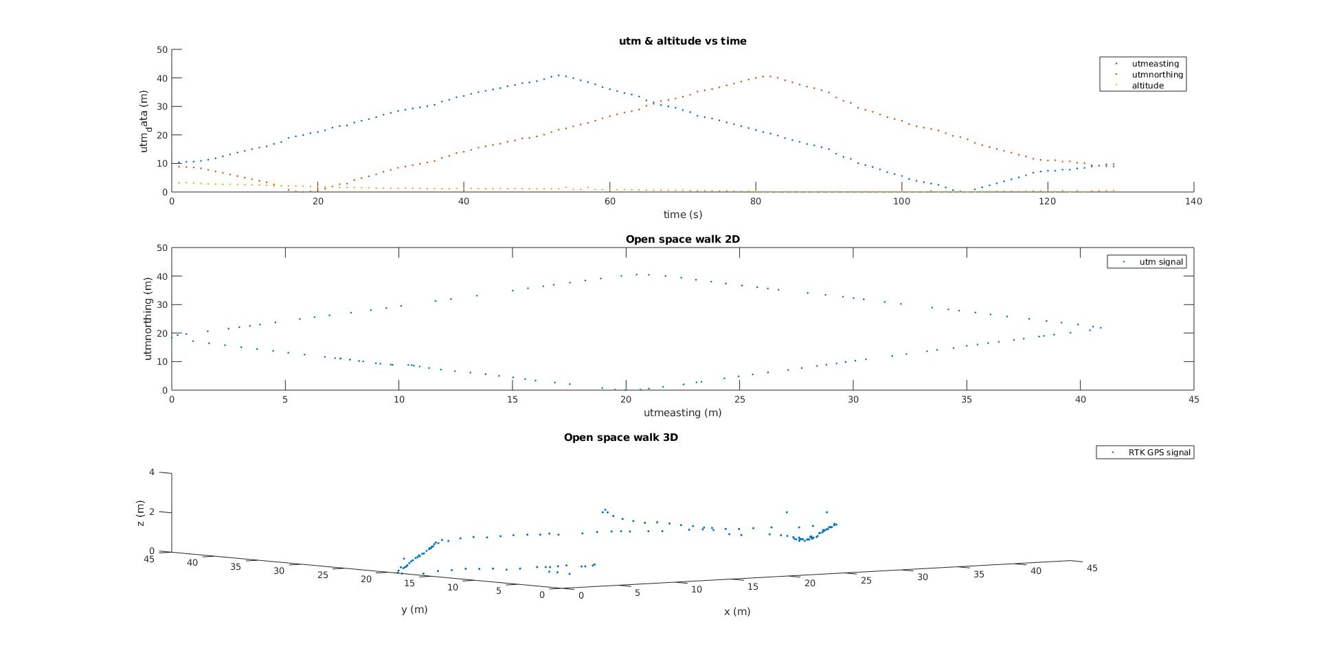

*Figure 6: Open Space walk RTK GPS plotting*

**Conclusion:**

As we can see in Figure 5, we walked a rectangle path near ISEC and the GPS signal was lost at some point due to the occlusion of buildings.

When we walked in a football field, RTK GPS provided high accurate data. For example, the value of altitude changed indicated that we picked up the rover GPS when we started to walk.

One interesting thing we found during the lab is, the time rover GPS takes to get stable output near ISEC is longer than that in open area. It is about 15 minutes in open space, whereas 25 minutes outside of ISEC. I think that’s because the base GPS required more time to get enough data for calibration.